Name:________________________

Mathematics: Methods Unit 1

Test 3, 2015
Trigonometric Functions and Equations, Probability

Calculator Free
25 marks

25 minutes

No Calculators Allowed

SCaSA Formula Sheet

Question 1 [1, 1, 1 = 3 marks]

Shade in the region described by the following:
A
B
- A ∩ B

B
C
- B ∪ C’

A
B
C
- (A ∪ B) ∩ C

Question 2 [3 marks]
From the following Venn Diagram:

Find:
Leave your answer in FRACTION form
- P(A ∪ B)

- P(A/B)

- P(A’ ∩ B)

Question 3 [8 marks]

State the exact value of each of the following.

a) $\sin{\frac{π}{3}}=$ b) $\sin^{2}{3+\cos^{2}{3=}}$

c) $\cos{\frac{π}{4}=}$ d) $\cos{150°=}$

e) $\sin{\frac{5π}{3}=}$ f) $\cos\left(nπ\right)$ where n is an odd integer

g) $\tan{210°}=$ h) $\sin\left(-\frac{π}{6}\right)=$

Question 4 [2, 3, 3 =8 marks]

Solve the following trigonometric equations. Show working.

- $\sin{x=-\frac{\sqrt{3}}{2}}$ in the interval $0≤x≤2π$

- $2\sin^{2}{x=\frac{1}{2}}$ in the interval $0°≤x≤360°$

- $\cos{2x=\frac{1}{2}}$ in the interval $0°≤x≤180°$

Question 5 [3 marks]

The graph below is of the general equation $y=\cos\left(a(x+b)\right)+c$.
Determine the values of a, b and c.

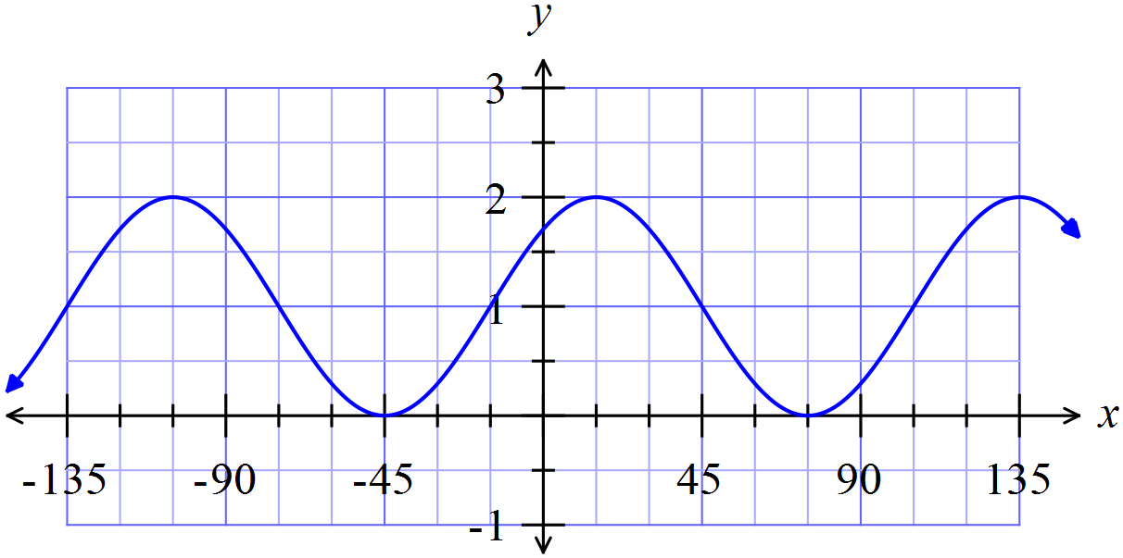

Name:________________________

Mathematics: Methods Unit 1

Test 3, 2015
Trigonometric Functions and Equations, Probability

Calculator Assumed
30 marks

30 minutes

Approved Calculators Allowed

A4 Page of Notes

SCaSA Formula Sheet

Question 6 [3, 4 = 7 marks]

Amos asked Lara what she would like for lunch and offered her several choices:
In her sandwich she could have jam, peanut paste or chicken.
As a sweet she could have a Mars Bar or a jam donut.
For fruit she could have a banana, an apple or a pear
Lara never has two jam items on the same day, and if she has a Mars Bar she always selects an apple for fruit.

- Draw a tree diagram showing all possible combinations of lunches for Lara if it is known that she took a sandwich, a sweet and a piece of fruit.

- Use the tree diagram to determine the following probabilities:

- she chooses a jam sandwich

- she has an apple and a Chicken sandwich

- she chooses a jam donut or an apple

- she chose a chicken sandwich given that she chose an apple

Question 7 [2, 2 =4 marks]

State the period and amplitude for each of the following.

- 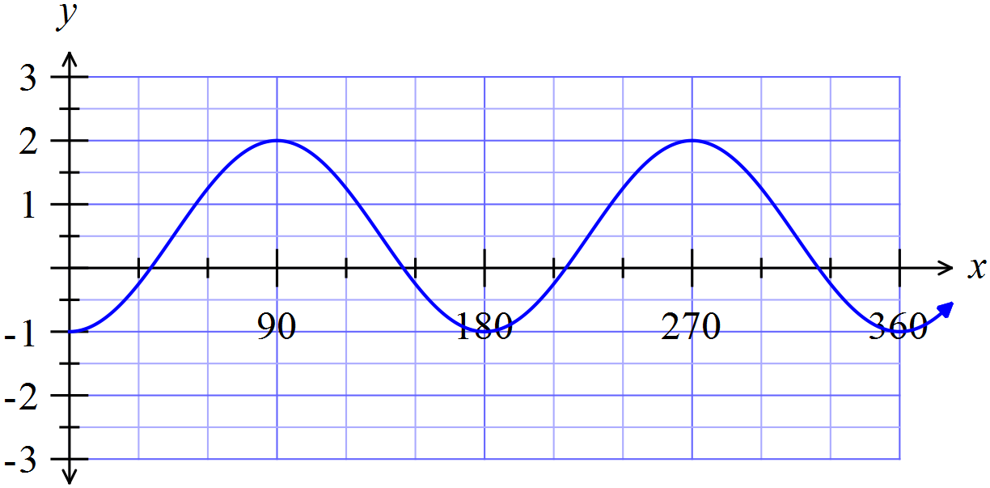

- $y=-\tan\left(x+\frac{π}{4}\right)$

Question 8 [1, 1, 1 =3 marks]

Given the graph below of a sinusoidal function, determine its:
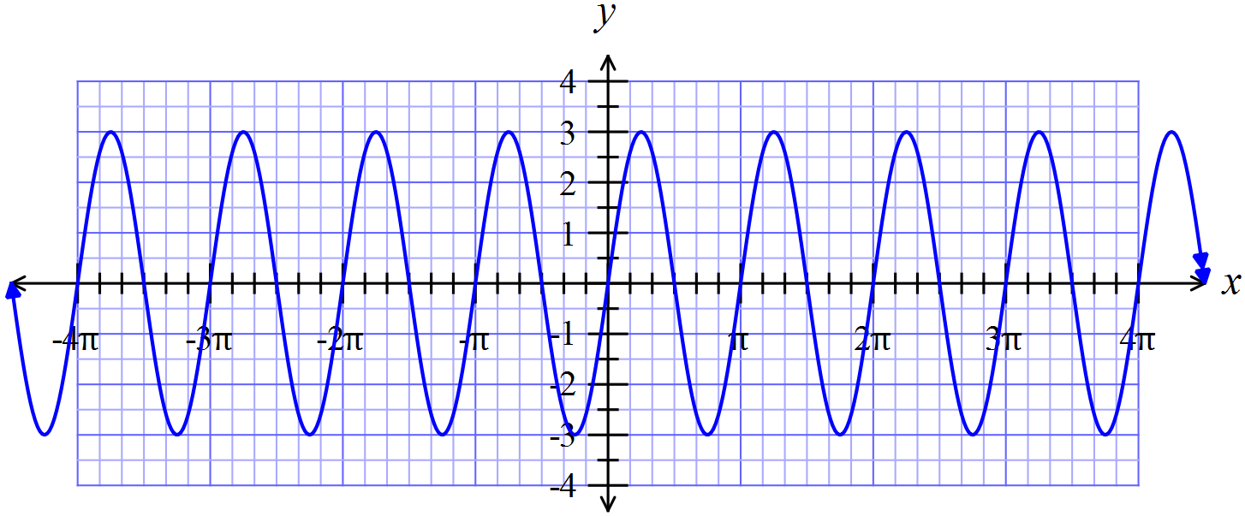

- amplitude

- period

- equation

Question 9 [2, 1, 2, 2 =7 marks]

A student travelling to school has to pass through two sets of traffic lights A and B that operate independently of each other. The probabilities that she will be stopped at these lights are $\frac{5}{8}$ and $\frac{7}{10}$ respectively, with corresponding delays of 2 minutes and 3 minutes. Without these delays her journey takes 20 minutes.
- Complete the tree diagram, entering the appropriate probabilities in the given brackets.
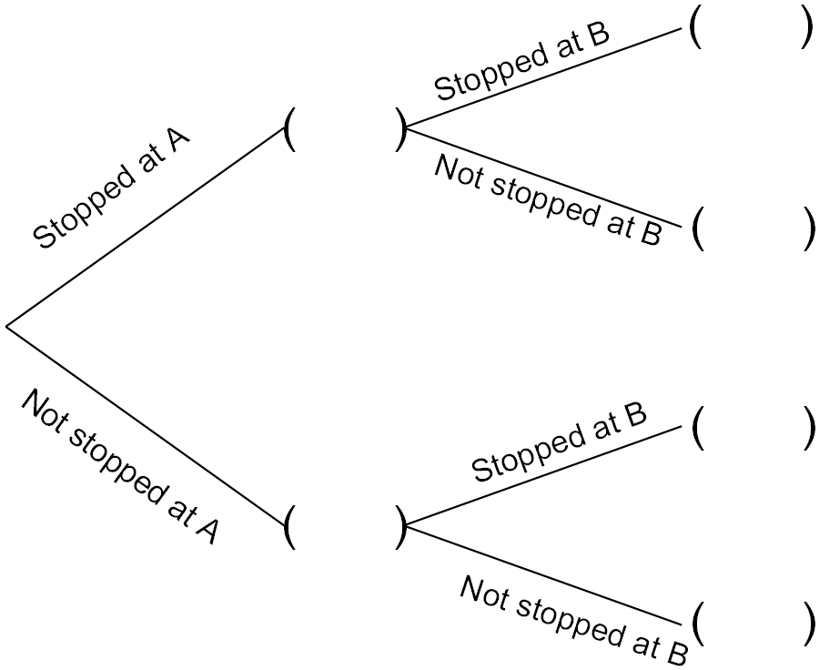

- Determine the probability that

- The journey takes no more than 20 minutes.

- The student encounters just one delay

- One morning the student has only 22 minutes to reach school on time. Determine the probability that she will be late.

Question 10 [1, 4 =5 marks]

If $\sin{A=\frac{4}{5}}$ and $\cos{B=-\frac{7}{25}}$ where $0≤A≤\frac{π}{2}$ and B is obtuse, determine exactly:

- $\tan{A}$

- $\sin\left(A+B\right)$

Question 11 [4 marks]

For two events A and B, P(A) = 0.3 and P(A ∪ B) = 0.6

Determine P(B) if events A and B are independent.

